WEDE5020 – POE- PART1

st10152042-prisca mudimbi

Contents

Website Choice 2

Name 2

Description 2

Reason for choosing the organisation 2

Website Assets 2

Images 2

Text 2

Website Pages and Content 3

Homepage 3

Logo 3

Slogan 3

Links to other pages 3

Full‐width photo 3

Summary of main activities of the organization. 4

Basic contact info. 4

Copyright / Year. 4

# Website Choice

## Name

Girlee Collection

Domain: www.girleecollection.com

## Description

The online store will provide timeless classics to contemporary trends, our products will empower you to express your unique personality through fashion. I have made so much changes compare to the first design and even the colour choices is quite different.

## Reason for choosing the organisation

I chose this website because it something that I personally own, and I am working on expanding my business to become well know. This website is about style and sophistication, where elegance meets individuality. At our boutique, we create a collection that celebrates the strength and beauty of every woman and few men products with some African touch. I am here to provide timeless classics to contemporary trends, our products will empower you to express your unique personality through fashion. My vision is to provide shoppers who appreciate unique mix of African designs and top quality pieces you just can’t find anytime elsewhere. We are constantly curating fresh new collections and looking for the next big thing our customers will love. Our mission is to provide our customer with good quality products whether it single I already do have social media page that I still make use to display items once there is any availability for it.

Now that I am going to develop a website for it , it will allow me to link it to my social page and I will have more publicity. People can just navigate to each of the pages and the can fill forms to contact and place orders too. This will be a great deal for me because then I can then keep record of all the orders and increase and decrease of stock etc.

# Website Assets

These are the following new set collection of the assets plus some of the old collection that will be used throughout the website. These fall in line with the company branding.

## Images

Image 1 below will be used on the home page.

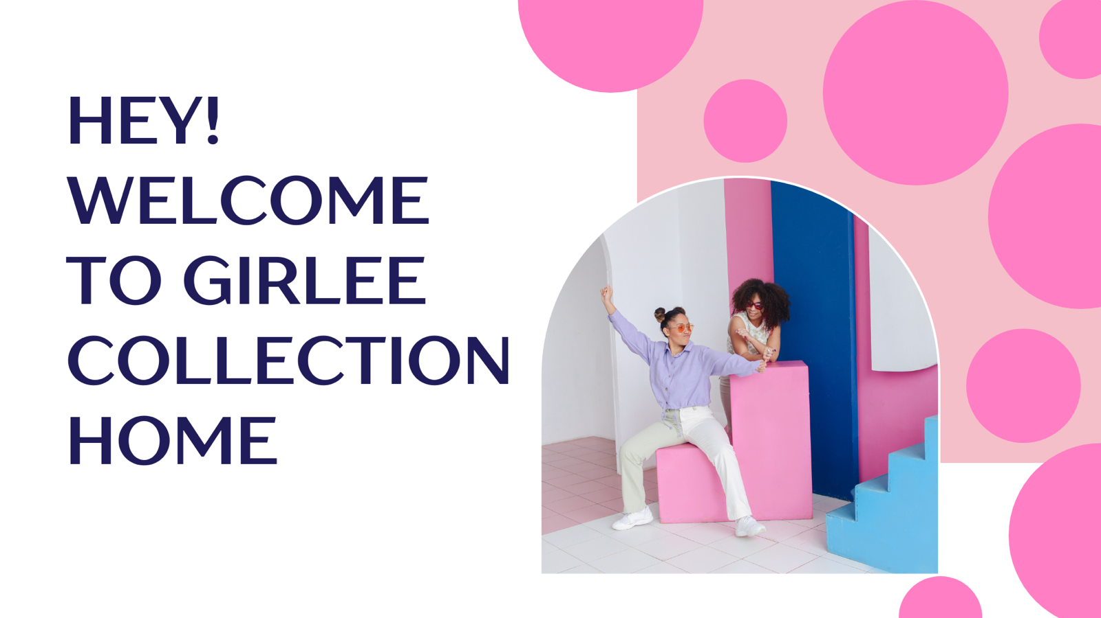

Image 2 below will be used on the gallery.

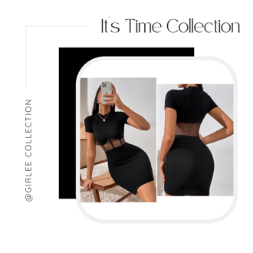 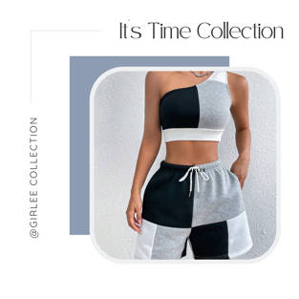 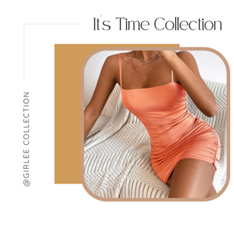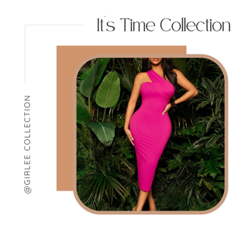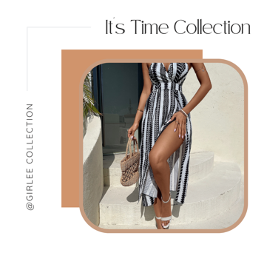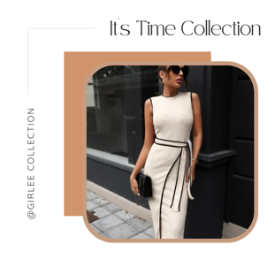

## Text

We are here to provide you with loads of collections and different products starting from head to toe.

Fonts : Lucida Console , arial etc

Colours: blue. Pink, purple and white and black and white for the text.

# Website Pages and Content

## Homepage

### As for my Logo I have made use of it in the contact page , yet I used the name .

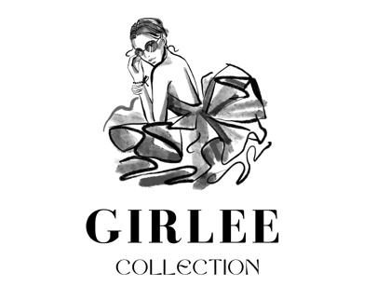

The logo will display at the top of the Homepage at a later stage but it will be found on the contact page.

About Page –

Image used

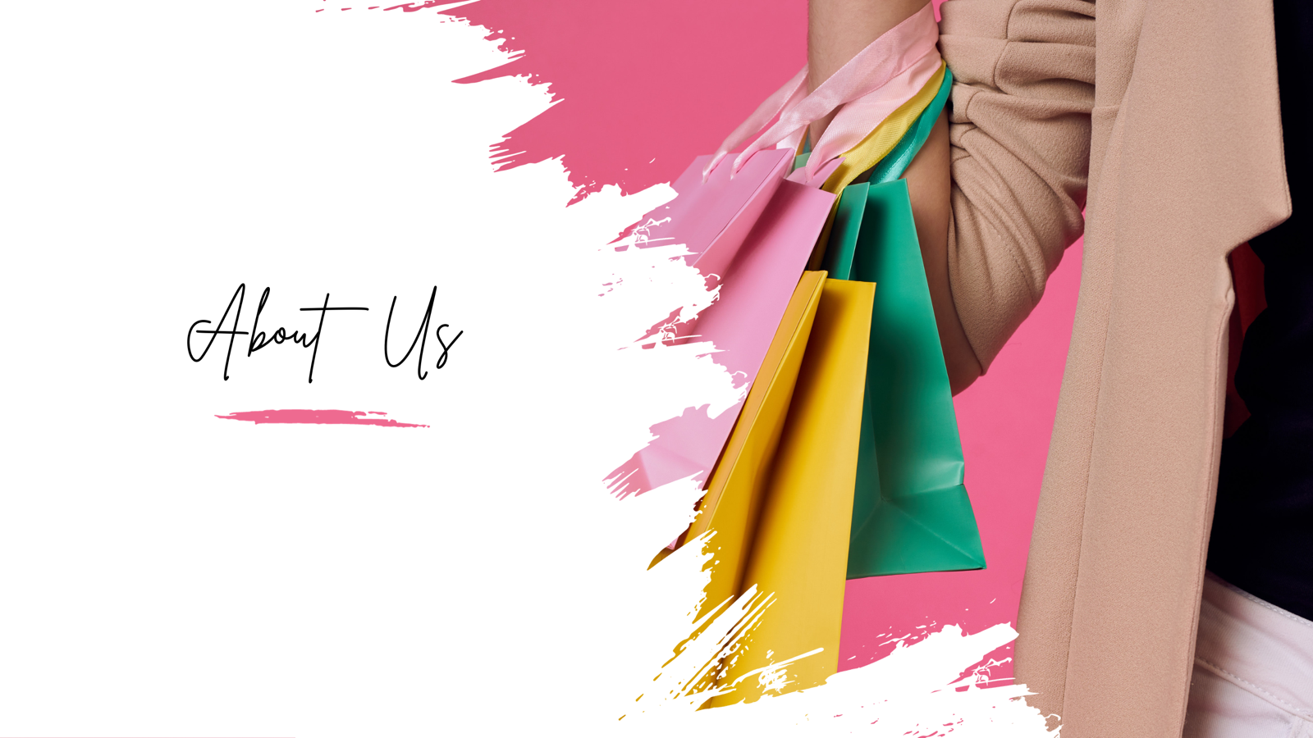

About us

We are here to provide timeless classics to contemporary trends, our   
products will empower you to express your unique personality through fashion.

Vision

Our vision is to provide shoppers who appreciate unique mix of African designs and   
top quality pieces you just can't find anytime elsewhere   
We are constantly curating fresh new collections and looking for the next big thing our customers will love.

Mission

Our mission is to provide our customer with good quality products whether it single or bulk.

Contact Us Page -

### Full‐width photo

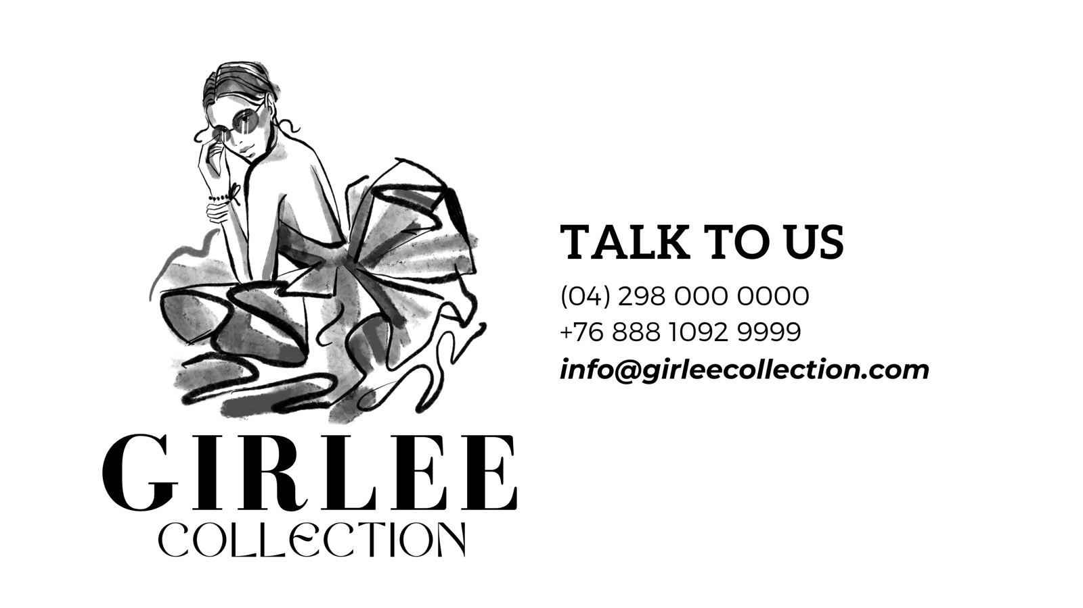

This is an idea of the kind of product we want to offer.

## Summary of main activities of the organization.

This brand is specialize in selling products that celebrates the strength and beauty of every woman and few men products with some African touch.

## Basic contact info.

Address: 21 royal road,Maitland 7504

Telephone: +27 21 544 3333/ +27 544 0000

Email: info@girllecollection.com

## Copyright / Year.

Copyright 2023

Services page

At our boutique, we create a collection that celebrates the strength and beauty of every woman and few men products with some African touch.

Here below is all that we offer and the order process

All of this have to do with the

* ordering process
* our products
* notices and messages announcements
* shipment

